#### **JUST-LOAN Capstone**

**About JustLoan**

JustLoan is a financial institution dedicated to providing accessible, customer-centric loan solutions to individuals and businesses. Established to support the diverse borrowing needs of customers, JustLoan's offerings range from personal and business loans to specialized financing options for various sectors. The company prides itself on its swift, data-driven decision-making process, aimed at delivering customized loan products based on a comprehensive evaluation of each applicant's financial profile.

To manage the data effectively, JustLoan maintains detailed records of loan applications. This assignment contains real-world inspired data from JustLoan's loan application database, detailing multiple aspects of each applicant's profile, which help the company assess creditworthiness and decide on loan terms.

**Data Overview**

The following table outlines each column in the dataset and its significance in the loan

application process at JustLoan:

**1. Loan Application Date:** The date on which the loan application was submitted.

This data helps JustLoan track application trends over time.

**2. CustomerID:** A unique identifier assigned to each applicant. CustomerID is

critical for tracking individual application histories, cross-referencing with other

records, and ensuring data privacy.

**3. Department - Designation:** The applicant's current department and designation

within their organization, indicating their employment field and role. This

information helps JustLoan evaluate income stability, as certain departments or

roles may be deemed higher or lower risk based on industry trends.

**4. Credit Score:** The credit score of the applicant, reflecting their creditworthiness.

A higher score indicates lower credit risk, while a lower score may require further

scrutiny or a higher interest rate to offset risk.

**5. Past Loans:** The total number of loans the applicant has previously taken. This

data offers insight into the applicant's borrowing history and experience with

loan repayment.

**6. EMI Defaults:** The count of missed EMI (Equated Monthly Installment) payments

across previous loans. A higher number of EMI defaults signals potential risk, as

it indicates prior difficulty in meeting payment obligations.

**7. Date of Birth:** The applicant's date of birth, helps JustLoan determine the

applicant's age. Age is an important factor in assessing the applicant's earning

potential and repayment ability.

**8. New Loan Application Amount:** The amount requested in the current loan

application. By analyzing application amounts, JustLoan can tailor loan products

and suggest appropriate options to customers based on historical data.

**9. Loan type:** Type of loan the applicant applies the loan for.  
  
Task 1:

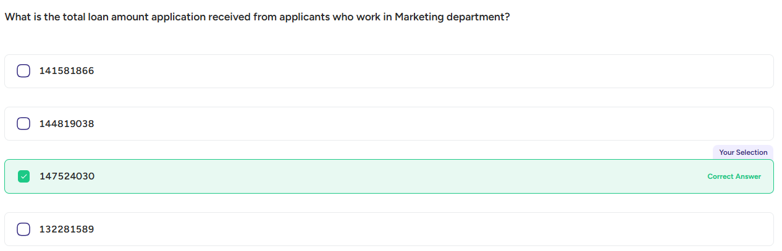

Task 2:

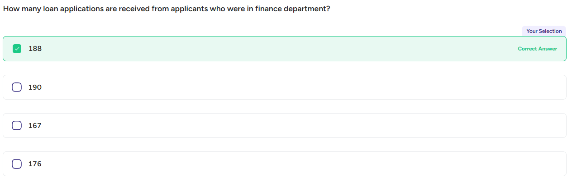

Task 3:

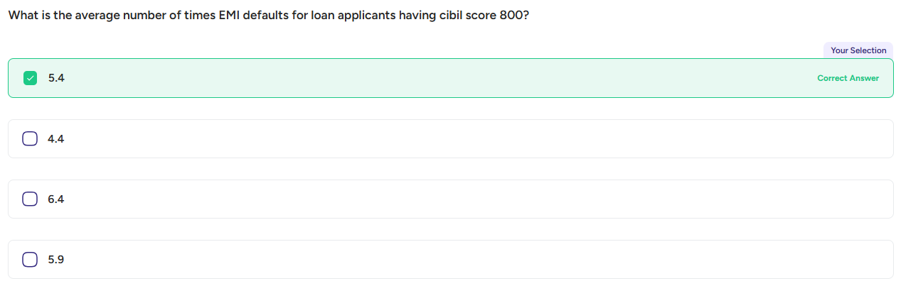

Task 4:

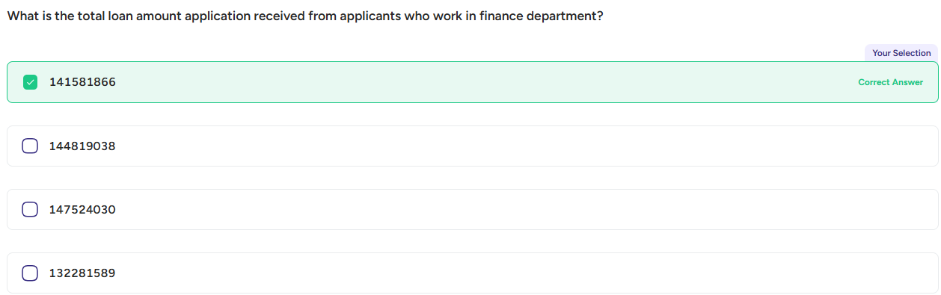

Task 5:

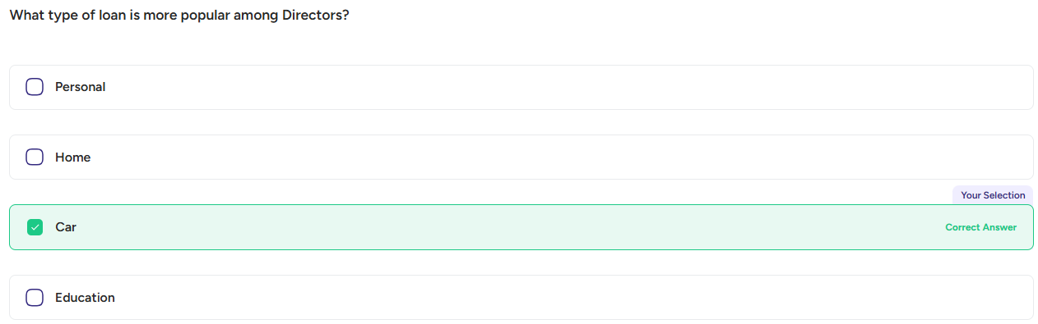

Task 6:

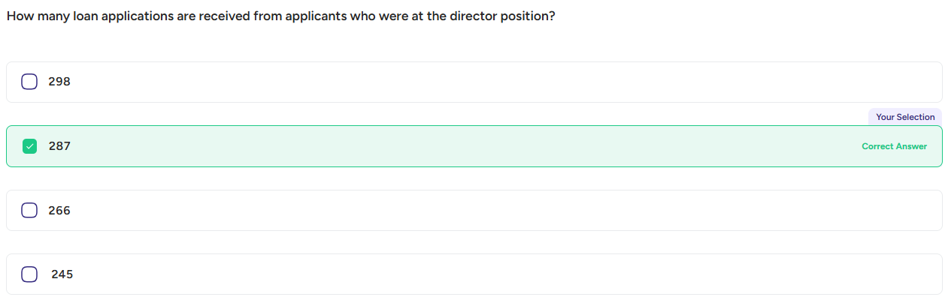

Task 7:

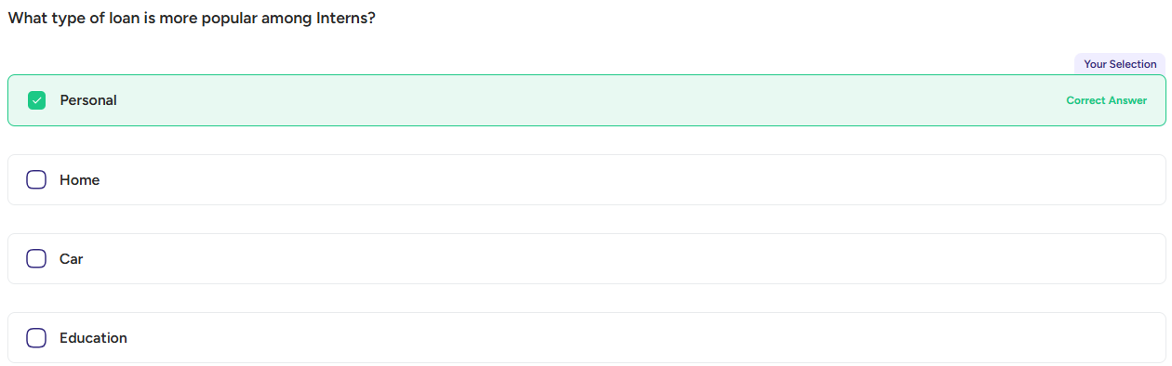

Task 8:

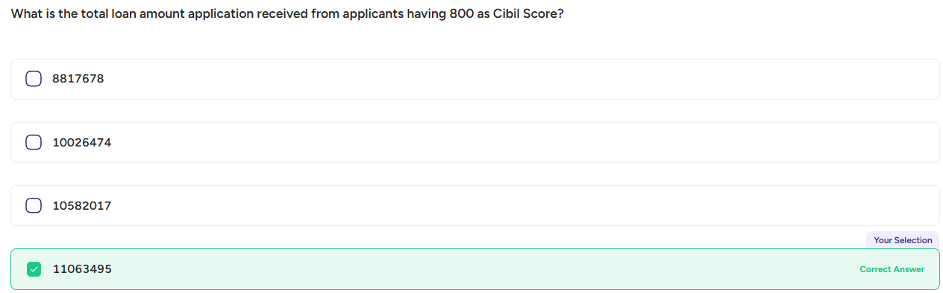

Task 9:

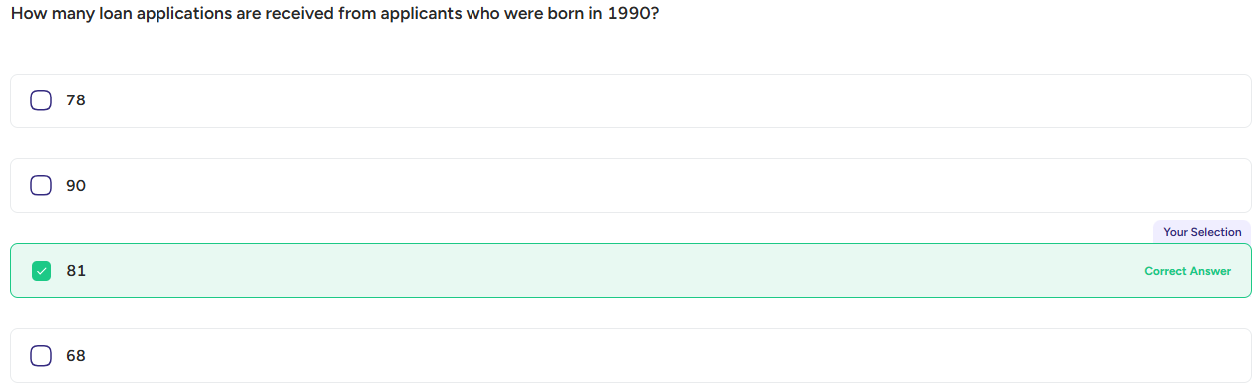

Task 10:

